Alexander Baldree
06/10/26
Module 2.2 Assignment
CSD430

Git Hub Link:
https://github.com/Panda-Alex21687/CSD430

Java Version:
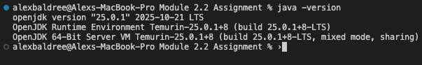

JavaFX Configured:
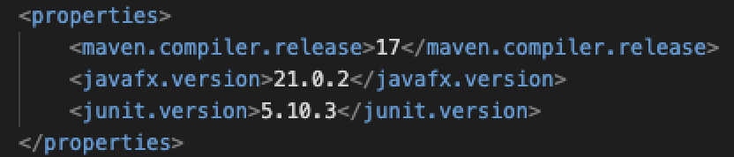

Apache-Tomcat Stated Successfully :
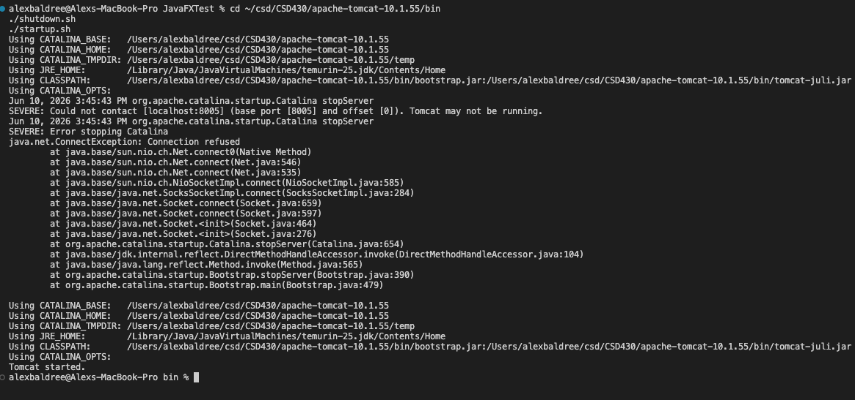

Webapps folder:
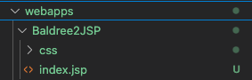
In the apache-tomcat folder:

Index.jsp file:

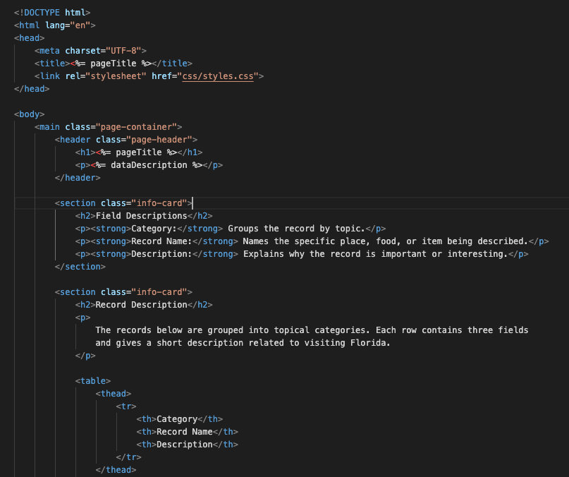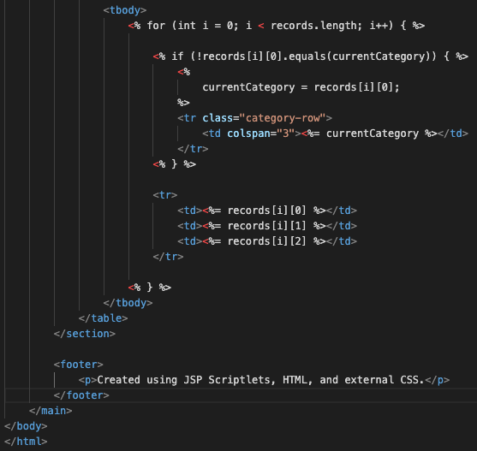
Style.css
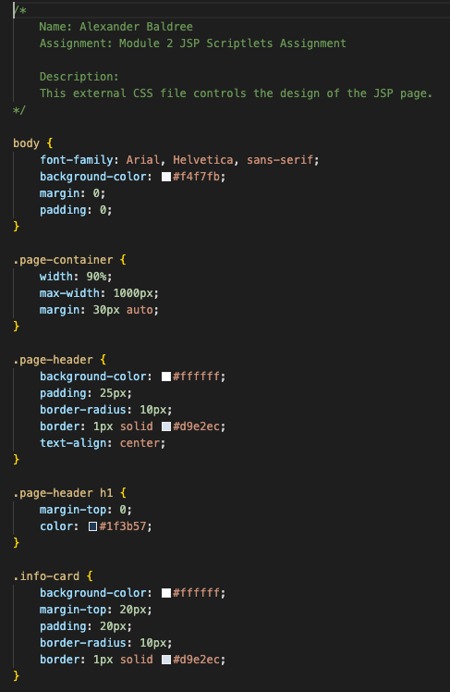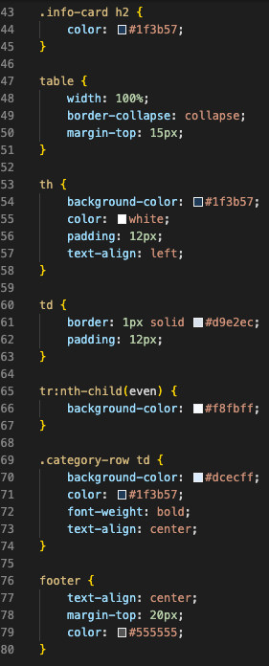

JSP running in Browser:
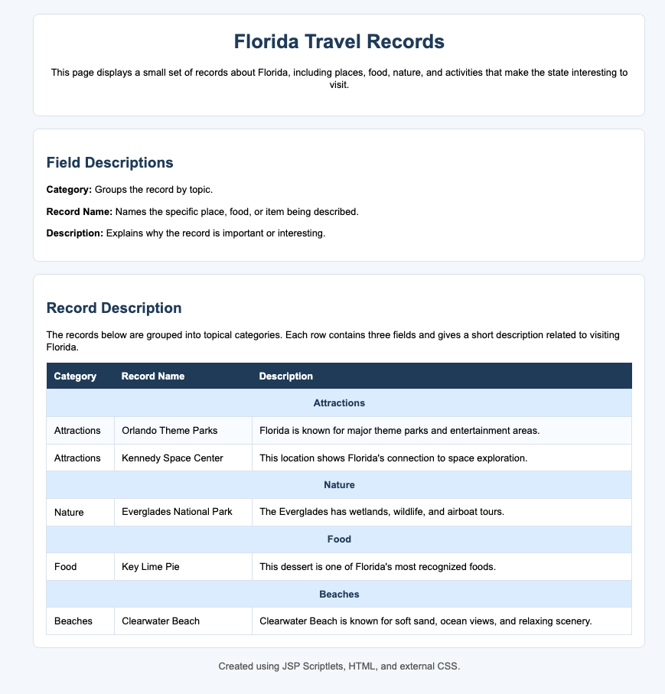
Terminal showing file location:
